COMMERCIAL CONSTRUCTION
INFORMATION PACKET

TABLE OF CONTENTS

General Requirements 2

General Inspection Notes 2

Inspections Required 3

Inspection Requirements 4

T-Pole 4

Flatwork 5

Plumbing Rough 5

Foundation 5

Utility Final 5

Building Final 5
Mechanical Final 6

Electrical Final 6

Plumbing Final 6
Fee Schedule ……………………………………………………………………… 7

A. GENERAL REQUIREMENTS

1. Plan/Permit Submittal
a. Three (3) complete sets of plans on sheets that are not larger than 24” X 36”.
- A cover sheet that includes the following information:
1. Building construction type (II-N, V-N, etc.).
- Occupancy classification (E-2, B, M, etc.).
- Number of parking spaces required and provided.
- Total square footage of building.
- Occupant load (based on the International Building Code).
- Exiting requirements. Indicate the number of exits required and provided as well as the exit width required and provided.
- Whether or not the structure is contains an automatic fire sprinkler system.
- Whether or not the structure contains a fire alarm and if so what type.
- Complete address of proposed building along with the correct legal description.
- Three (3) site plans indicating all proposed structures and where those structures are to be placed in relation to property lines.
- Three (3) complete floor plan of the structure(s).
- Window and door sizes must be included with each of the floor plans.
- Three (3) elevation drawings showing exterior wall construction.
- Three (3) foundation drawings stamped by a professional engineer licensed by the State of Texas.
- One (1) original letter from the same engineer that designed and sealed the foundation plans stating that the foundation was designed for the soil conditions on that particular lot. The letter must also state that the foundation design criteria complies with the minimum standards required by the 2003 International Building Code..
2. No construction, other than setting form boards and lot grading, may begin until a building permit has been issued.
4. Building permit cards must be displayed in an obvious place that can be seen by the public. Permit cards and previous inspection tags must be contained in the zip lock plastic bag provided by the City. Construction plans stamped approved by the Building Inspection Division must remain on the job site at all times.
5. No tracked vehicles will be allowed on streets and alleys that have been accepted by the City.
6. Instruct subcontractors and their employees to park in such a way that emergency vehicular traffic will not be obstructed, i.e., fire trucks and ambulances.
7. Building addresses must be posted at each lot at all times. Numbers must be a minimum of twelve inches (12") in height and face a public street.
8. Addresses must be posted on all temporary electrical poles.
9. A trash container with a minimum dimension of six feet by six feet by four feet high (6' X 6' X 4') is required at all times on the job site. Openings in the walls of the trash container cannot be large enough to allow a two-inch (2") diameter or larger sphere to pass through.

B. GENERAL INSPECTION NOTES

- All inspections must be requested by calling City Hall (903) 560-8169 or (903) 873-2578.
- For general questions only and for permit information, you may call City Hall.
- Cancellations. Inspections should not be requested until the contractor has verified that the work is complete and ready for inspection.

C. INSPECTIONS REQUIRED

Inspections required for building construction types are outlined below:

1. Free-standing buildings:

Inspections
- Temporary Pole (can be done at any time)
- Flatwork
- Plumbing Rough
- Grease Trap
- Tilt Wall
- Foundation
- Structural Steel Report (if applicable) before the wall inspection.
- Framing/Electrical/Plumbing Wall inspection
(Wall framing, electrical lines in walls and plumbing –
must be done at the same time)
- Ceiling Inspection (Electrical, Mechanical –
all must be done at the same time)
- Duct Wrap Inspection
- Grease Duct or Hood Inspection
(for restaurant occupancies)
- Utility Final
- Building Final
(Energy code certification must be submitted prior to requesting this inspection)
- Mechanical Final
- Electrical Final
- Plumbing Final

- Shell Buildings:

Inspections
- Temporary Pole (can be done at any time)
- Plumbing Rough
- Grease Trap
- Tilt Wall Inspection
- Foundation
- Structural Steel Report (if applicable), before the wall inspection.
- Framing/Electrical/Plumbing Wall inspection
- Ceiling inspection
- Utility Final
- Building Final
(Energy code certification must be submitted prior to requesting this inspection)
- Mechanical Final
- Electrical Final
- Plumbing Final

- Interior Finish-Out:

Inspections
- Plumbing Rough
- Grease Trap
- Leave Out
- Framing/Electrical/Plumbing Wall inspection
- Ceiling inspection
- Duct Wrap Inspection
- Grease Duct/Kitchen Hood
- Utility Final
- Building Final
(Energy code certification must be submitted prior to requesting this inspection)
- Mechanical Final
- Electrical Final
- Plumbing/Mechanical Final

4. Special Inspections

Certain types of special inspections will also be required. Special inspection can be performed by a qualified testing lab or professional engineer. Reports from the special inspector must be submitted to the Building Inspector for review. Additional reports or testing may be necessary before the special inspection reports can be approved by the Building Inspector.

Items requiring special inspection include:

Structural Steel - reports must verify that the structural steel has been installed in accordance with the engineered design. Also, the reports must verify that all connections have been made correctly (i.e. welds, bolts, etc.)

Energy Code Certification – All jobs must receive all required energy inspections before a building final inspection can be approved.

Items that may utilize a special inspector in place of a City of Wills Point inspector include (Provided that prior approval is received from the Building Official to use the services of the special inspector):

Piers - reports must verify the depth, diameter and conditions of the pier hole.

Other special inspections or engineered plans or documents may be required by the Building Official as outlined in the Uniform Building Code.

D. INSPECTION REQUIREMENTS

1. TEMPORARY POWER POLE

a. Double pole breaker installed for 220 volt plug.
b. Single pole breaker installed for 120 volt plug with GFCI protection on all 120 volt receptacles.
c. Box is to be secured to the pole.
d. Pole is to be braced.
- A ground rod must be installed.
- Legible address numbers must be posted on the T-pole. Numbers must be at least three inches (3") in height.

2. FLATWORK (City Sidewalks, Parking Lots and Drive Approaches Only)

All City sidewalks, approaches and parking lots must be inspected prior to placement of concrete.

3. PLUMBING ROUGH

Plumbing rough inspections may be conducted in wet weather provided that a five (5) p.s.i. air test is placed on the sewer lines. When the inspection is requested, it must be stated that there is an air test on the sewer.

Plumbing rough inspections cannot be performed if the temperature is below freezing unless an air test has been placed on the sanitary sewer lines and the water distribution lines. An air test may be placed on the system when freezing conditions occur.

4. FOUNDATION (All foundation plans must be stamped by a structural engineer) (An original form board survey stamped by a licensed surveyor must be located on the construction site and kept on file at City Hall. The survey must verify that all property line setback requirements are met.)

8. UTILITY FINAL (Inspection approval allows for release of utility meters)

- Cover must be off of main panel box.
- Grounding electrode system must be complete.
- Neutral and ground conductors must be properly coded and identified.
- Required fixtures and equipment installed and wired.
e. Required receptacles installed and wired.
f. A gas test of at least ten pounds per square inch (10 psi) is required. The test must be performed on a thirty (30) pound gauge.
g. All open gas lines and shut-off valves must be capped. A shut-off valve does not eliminate the requirement to cap the line.

9. BUILDING FINAL

- All equipment must be installed, wired and working properly.
- A permanent address must be installed on the front of the building with 3" numbers of contrasting color to background.
- Street, alley, and all flatwork must be clean and clear of mud and debris.
- Parking areas must be properly striped. Fire lanes must be properly striped. Accessible parking spaces must be properly marked with signs and painting.
- All landscape work must conform with the approved landscape plan. Trees and shrubs must not be damaged or dead.
- Yard must be clear of debris and final grade completed.
- Exit signs must clearly identify the exit path from the building.
- All panic hardware must be installed. Exit doors must be able to open from the inside of the building without the use of a key or any special knowledge.

10. MECHANICAL FINAL

- Combustion air vents must be installed in the top and bottom portion of closets enclosing gas appliances. Each vent must total 100 square inches.
- All mechanical must be installed with all connections complete.

11. ELECTRICAL FINAL

a. Electrical meter must be installed.
b. All receptacles and light fixtures must be installed, wired and working properly.
c. Circuits must be labeled with ink or typewriter in the breaker box.

10. PLUMBING FINAL

a. Gas meter must be installed.
b. All gas lines must be connected. Gas stops and caps must be installed on any gas line installed for future use.
c. All plumbing fixtures must be installed. Accessible toilets must have a clearance of at least 18" from any side wall or partition to the center of the toilet. All other toilets must have a clearance of at least 15" from any side wall or partition to the center of the toilet.
d. All hose bibs must be frost proof with integral vacuum breakers.
e. Sewer cleanouts must be cut to grade.
f. PVC vent stacks must be painted with latex paint.
g. Hot water must correspond to the left side of fittings on plumbing fixtures.
h. Unions must be installed within twelve inches (12") of regulation equipment, water heaters, conditioning tanks, or other similar equipment.

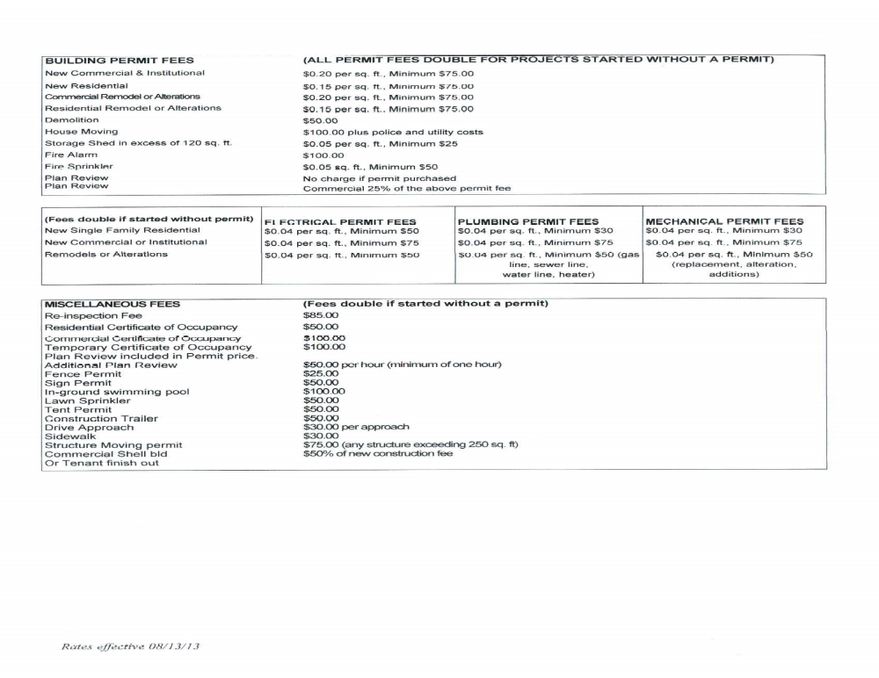
The above requirements are only a general list of building, electrical, plumbing, and mechanical code regulations. For a complete list of building requirements refer to:

2006 International Building Code
2006 International Mechanical Code

2005 National Electrical Code
2006 International Energy Conservation Code

