September 11, 2017
Economic Overview
City of Wills Point, TX
Demographic Profile 3
Employment Trends 5
Wage Trends 5
Cost of Living Index 6
Industry Snapshot 7
Occupation Snapshot 9
Industry Clusters 11
Education Levels 11
FAQ 12

Demographic Profile
In 2010, the population in the City of Wills Point, TX was 3,524.
The region has a civilian labor force of 1,546 with a participation rate of 58.9%. Of individuals 25 to 64 in the City of Wills Point, TX, 14.6% have a bachelor’s degree or higher which compares with 31.3% in the nation.
The median household income in the City of Wills Point, TX is $36,797 and the median house value is $75,800.
Summary¹
 | Percent |  |  | Value
 | City of Wills Point, TX | Texas | USA | City of Wills Point, TX | Texas | USA
Demographics
Population⁴ | — | — | — | 3,524 | 25,145,561 | 308,745,538
Median Age^{2,4} | — | — | — | 36.9 | 33.6 | 37.2
Under 18 Years⁴ | 27.8% | 27.3% | 24.0% | 981 | 6,865,824 | 74,181,467
18 to 24 Years⁴ | 8.6% | 10.2% | 9.9% | 302 | 2,572,969 | 30,672,088
25 to 34 Years⁴ | 11.6% | 14.4% | 13.3% | 410 | 3,613,473 | 41,063,948
35 to 44 Years⁴ | 11.8% | 13.8% | 13.3% | 417 | 3,458,382 | 41,070,606
45 to 54 Years⁴ | 12.5% | 13.7% | 14.6% | 441 | 3,435,336 | 45,006,716
55 to 64 Years⁴ | 10.2% | 10.3% | 11.8% | 360 | 2,597,691 | 36,482,729
65 to 74 Years⁴ | 7.6% | 5.9% | 7.0% | 268 | 1,472,256 | 21,713,429
75 Years, and Over⁴ | 9.8% | 4.5% | 6.0% | 345 | 1,129,630 | 18,554,555
Race: White⁴ | 81.0% | 70.4% | 72.4% | 2,856 | 17,701,552 | 223,553,265
Race: Black or African American⁴ | 11.8% | 11.8% | 12.6% | 417 | 2,979,598 | 38,929,319
Race: American Indian and Alaska Native⁴ | 0.7% | 0.7% | 0.9% | 26 | 170,972 | 2,932,248
Race: Asian⁴ | 0.3% | 3.8% | 4.8% | 11 | 964,596 | 14,674,252
Race: Native Hawaiian and Other Pacific Islander⁴ | 0.0% | 0.1% | 0.2% | 1 | 21,656 | 540,013
Race: Some Other Race⁴ | 4.3% | 10.5% | 6.2% | 150 | 2,628,186 | 19,107,368
Race: Two or More Races⁴ | 1.8% | 2.7% | 2.9% | 63 | 679,001 | 9,009,073
Hispanic or Latino (of any race)⁴ | 12.2% | 37.6% | 16.3% | 430 | 9,460,921 | 50,477,594
Economic
Labor Force Participation Rate and Size (civilian population 16 years and over) | 58.9% | 64.3% | 63.3% | 1,546 | 13,006,330 | 158,897,824
Armed Forces Labor Force | 0.2% | 0.5% | 0.4% | 6 | 95,458 | 1,015,464
Veterans, Age 18-64 | 3.2% | 5.6% | 5.5% | 58 | 927,000 | 10,750,884
Median Household Income² | — | — | — | $36,797 | $53,207 | $53,889
Per Capita Income | — | — | — | $22,567 | $26,999 | $28,930
Poverty Level (of all people) | 22.2% | 17.3% | 15.5% | 749 | 4,472,451 | 47,749,043
Households Receiving Food Stamps | 25.9% | 13.4% | 13.2% | 295 | 1,229,337 | 15,399,651
Mean Commute Time (minutes) | — | — | — | 27.0 | 25.6 | 25.9
Commute via Public Transportation | 0.0% | 1.6% | 5.1% | 0 | 188,363 | 7,362,038
Union Membership³ | 4.8% | 4.2% | 10.7% | — | — | —
Educational Attainment, Age 25-64
No High School Diploma | 15.0% | 16.8% | 11.8% | 228 | 2,320,136 | 19,736,243
High School Graduate | 38.5% | 24.7% | 26.4% | 584 | 3,407,798 | 43,982,863
Some College, No Degree | 24.3% | 22.9% | 21.7% | 369 | 3,159,912 | 36,187,232
Associate's Degree | 7.6% | 7.2% | 8.8% | 115 | 987,726 | 14,742,654
Bachelor's Degree | 10.3% | 19.1% | 19.9% | 157 | 2,638,055 | 33,245,950
Postgraduate Degree | 4.2% | 9.3% | 11.4% | 64 | 1,283,284 | 18,952,103
Housing
Total Housing Units | — | — | — | 1,320 | 10,305,607 | 133,351,840
Median House Value (of owner-occupied units)² | — | — | — | $75,800 | $136,000 | $178,600
Homeowner Vacancy | 4.5% | 1.7% | 1.9% | 32 | 101,302 | 1,492,691
Rental Vacancy | 17.9% | 7.8% | 6.4% | 100 | 298,444 | 2,949,366
Renter-Occupied Housing Units (% of Occupied Units) | 40.5% | 37.8% | 36.1% | 460 | 3,455,426 | 42,214,214
Occupied Housing Units with No Vehicle Available (% of Occupied Units) | 14.2% | 5.8% | 9.1% | 162 | 530,789 | 10,628,474
Social
Enrolled in Grade 12 (% of total population) | 2.2% | 1.5% | 1.4% | 79 | 388,995 | 4,451,334
Disconnected Youth⁵ | 9.2% | 3.4% | 3.0% | 26 | 51,037 | 518,859
Children in Single Parent Families (% of all children) | 50.7% | 35.3% | 34.8% | 496 | 2,371,156 | 24,408,909
With a Disability, Age 18-64 | 15.0% | 9.9% | 10.3% | 272 | 1,596,252 | 19,985,588
With a Disability, Age 18-64, Labor Force Participation Rate and Size | 34.2% | 44.1% | 41.0% | 93 | 703,313 | 8,185,456
Foreign Born | 3.7% | 16.6% | 13.2% | 129 | 4,399,080 | 41,717,420
Speak English Less Than Very Well (population 5 yrs and over) | 2.9% | 14.2% | 8.6% | 95 | 3,486,872 | 25,410,756
Source: JobsEQ®
1. ACS 2011-2015, unless noted otherwise
2. Median values for certain aggregate regions (such as MSAs) may be estimated as the weighted averages of the median values from the composing counties.
3. 2016; Current Population Survey, unionstats.com, and Chmura; county- and zip-level data are best estimates based upon industry-, MSA-, and state-level data
4. Census 2010
5. Disconnected Youth are 16-19 year olds who are (1) not in school, (2) not high school graduates, and (3) either unemployed or not in the labor force.

Employment Trends
As of 2017Q2, total employment for the City of Wills Point, TX was 1,857 (based on a four-quarter moving average). Over the year ending 2017Q2, employment increased 1.3% in the region.
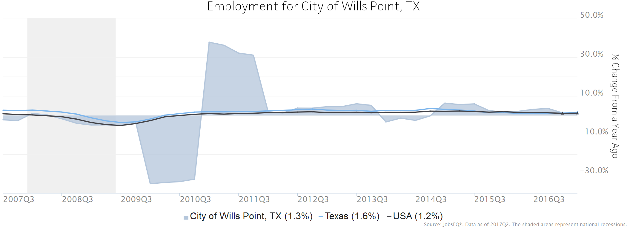
Employment data are derived from the Quarterly Census of Employment and Wages, provided by the Bureau of Labor Statistics and imputed where necessary. Data are updated through 2016Q4 with preliminary estimates updated to 2017Q2.

Wage Trends
The average worker in the City of Wills Point, TX earned annual wages of $32,769 as of 2017Q2. Average annual wages per worker increased 0.3% in the region during the preceding four quarters. For comparison purposes, annual average wages were $53,284 in the nation as of 2017Q2.
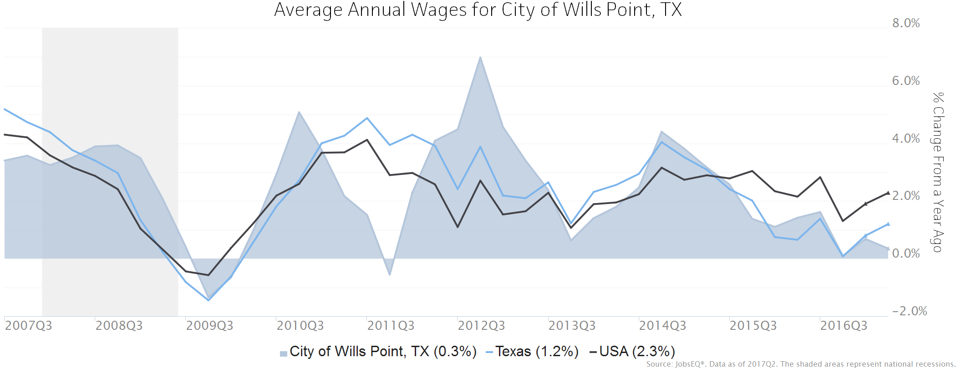
Annual average wages per worker data are derived from the Quarterly Census of Employment and Wages, provided by the Bureau of Labor Statistics and imputed where necessary. Data are updated through 2016Q4 with preliminary estimates updated to 2017Q2.

Cost of Living Index
The Cost of Living Index estimates the relative price levels for consumer goods and services. When applied to wages and salaries, the result is a measure of relative purchasing power. The cost of living is 7.9% lower in City of Wills Point, TX than the U.S. average.
Cost of Living Information
 | Annual Average Salary | Cost of Living Index (Base US) | US Purchasing Power
City of Wills Point, TX | $32,769 | 92.1 | $35,588
Texas | $53,426 | 93.9 | $56,871
USA | $53,284 | 100.0 | $53,284
Source: JobsEQ®
Data as of 2017Q2
Cost of Living per C2ER, data as of 2017q1, imputed by Chmura where necessary.

Industry Snapshot
The largest sector in the City of Wills Point, TX is Educational Services, employing 419 workers. The next-largest sectors in the region are Manufacturing (232 workers) and Retail Trade (203). High location quotients (LQs) indicate sectors in which a region has high concentrations of employment compared to the national average. The sectors with the largest LQs in the region are Educational Services (LQ = 2.74), Agriculture, Forestry, Fishing and Hunting (2.20), and Utilities (1.60).
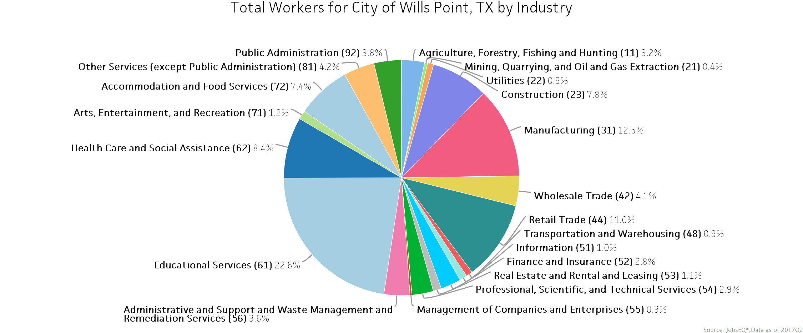
Employment data are derived from the Quarterly Census of Employment and Wages, provided by the Bureau of Labor Statistics and imputed where necessary. Data are updated through 2016Q4 with preliminary estimates updated to 2017Q2.
Sectors in the City of Wills Point, TX with the highest average wages per worker are Management of Companies and Enterprises ($69,996), Transportation and Warehousing ($68,180), and Professional, Scientific, and Technical Services ($55,818). Regional sectors with the best job growth (or most moderate job losses) over the last 5 years are Manufacturing (+110 jobs), Retail Trade (+67), and Educational Services (+57).
Over the next 10 years, employment in the City of Wills Point, TX is projected to expand by 120 jobs. The fastest growing sector in the region is expected to be Health Care and Social Assistance with a +2.3% year-over-year rate of growth. The strongest forecast by number of jobs over this period is expected for Health Care and Social Assistance (+40 jobs), Construction (+24), and Retail Trade (+16).
 |  | Current |  |  | Historical |  |  |  | Forecast
 |  | Four Quarters Ending with 2017q2 |  |  | Total Change over the Last 5 Years | Average Annual % Change in Employment 2012q2-2017q2 |  |  | Over the Next 10 Years
NAICS | Industry | Empl | Avg. Annual Wages | Location Quotient | Empl | City of Wills Point, TX | Texas | USA | Total Approx Repl Demand | Total Growth Demand | Avg. Annual Growth Percent
11 | Agriculture, Forestry, Fishing and Hunting | 59 | $12,638 | 2.20 | -68 | -14.3% | 0.5% | 0.8% | 20 | -1 | -0.2%
21 | Mining, Quarrying, and Oil and Gas Extraction | 7 | $49,350 | 1.00 | 7 | 56.3% | -3.3% | -4.9% | 2 | 1 | 0.7%
22 | Utilities | 16 | $47,070 | 1.60 | 3 | 3.7% | 0.3% | 0.1% | 4 | 2 | 1.3%
23 | Construction | 146 | $41,236 | 1.42 | -6 | -0.8% | 3.3% | 3.2% | 31 | 24 | 1.6%
31 | Manufacturing | 232 | $45,186 | 1.52 | 110 | 13.6% | -0.2% | 0.8% | 53 | -10 | -0.4%
42 | Wholesale Trade | 76 | $51,537 | 1.05 | 42 | 17.1% | 1.7% | 0.9% | 17 | 4 | 0.5%
44 | Retail Trade | 203 | $28,724 | 1.02 | 67 | 8.3% | 2.4% | 1.3% | 65 | 16 | 0.8%
48 | Transportation and Warehousing | 16 | $68,180 | 0.21 | -8 | -7.4% | 3.5% | 2.7% | 4 | 0 | 0.0%
51 | Information | 19 | $35,808 | 0.52 | -20 | -13.4% | 0.3% | 0.8% | 4 | -3 | -1.5%
52 | Finance and Insurance | 52 | $46,822 | 0.70 | -8 | -2.8% | 2.4% | 1.1% | 13 | 3 | 0.6%
53 | Real Estate and Rental and Leasing | 21 | $38,044 | 0.67 | 6 | 6.9% | 3.0% | 1.9% | 5 | 0 | 0.0%
54 | Professional, Scientific, and Technical Services | 55 | $55,818 | 0.45 | -5 | -1.9% | 3.6% | 2.4% | 12 | 7 | 1.2%
55 | Management of Companies and Enterprises | 5 | $69,996 | 0.18 | 5 | n/a | 7.4% | 2.9% | 1 | 0 | 0.6%
56 | Administrative and Support and Waste Management and Remediation Services | 66 | $42,857 | 0.55 | 6 | 2.0% | 2.7% | 2.6% | 16 | 9 | 1.3%
61 | Educational Services | 419 | $30,625 | 2.74 | 57 | 3.0% | 1.6% | 0.7% | 88 | 5 | 0.1%
62 | Health Care and Social Assistance | 156 | $30,087 | 0.59 | -48 | -5.2% | 2.8% | 2.5% | 33 | 40 | 2.3%
71 | Arts, Entertainment, and Recreation | 22 | $15,051 | 0.60 | 8 | 9.7% | 3.8% | 2.3% | 7 | 3 | 1.2%
72 | Accommodation and Food Services | 138 | $16,609 | 0.83 | 27 | 4.4% | 4.1% | 3.0% | 50 | 11 | 0.8%
81 | Other Services (except Public Administration) | 79 | $20,660 | 0.96 | 30 | 9.9% | 1.1% | -0.2% | 20 | 5 | 0.6%
92 | Public Administration | 70 | $33,439 | 0.79 | 27 | 10.4% | 0.7% | 0.1% | 17 | 4 | 0.6%
 | Total - All Industries | 1,857 | $32,769 | 1.00 | 229 | 2.7% | 2.3% | 1.7% | 464 | 120 | 0.6%
Source: JobsEQ®
Employment data are derived from the Quarterly Census of Employment and Wages, provided by the Bureau of Labor Statistics and imputed where necessary. Data are updated through 2016Q4 with preliminary estimates updated to 2017Q2. Forecast employment growth uses national projections adapted for regional growth patterns.

Occupation Snapshot
The largest major occupation group in the City of Wills Point, TX is Education, Training, and Library Occupations, employing 286 workers. The next-largest occupation groups in the region are Office and Administrative Support Occupations (235 workers) and Sales and Related Occupations (182). High location quotients (LQs) indicate occupation groups in which a region has high concentrations of employment compared to the national average. The major groups with the largest LQs in the region are Education, Training, and Library Occupations (LQ = 2.72), Production Occupations (1.51), and Construction and Extraction Occupations (1.29).
Occupation groups in the City of Wills Point, TX with the highest average wages per worker are Management Occupations ($88,600), Legal Occupations ($87,000), and Computer and Mathematical Occupations ($67,900). The unemployment rate in the region varied among the major groups from 0.9% among Management Occupations to 7.0% among Food Preparation and Serving Related Occupations.
Over the next 10 years, the fastest growing occupation group in the City of Wills Point, TX is expected to be Healthcare Support Occupations with a +2.3% year-over-year rate of growth. The strongest forecast by number of jobs over this period is expected for Construction and Extraction Occupations (+16 jobs) and Healthcare Practitioners and Technical Occupations (+13). Over the same period, the highest replacement demand (occupation demand due to retirements and workers moving from one occupation to another) is expected in Education, Training, and Library Occupations (63 jobs) and Food Preparation and Serving Related Occupations (63).
Occupation Snapshot in City of Wills Point, TX
 |  | Current |  |  |  |  | Historical |  |  |  | Forecast
 |  | Four Quarters Ending with 2017q2 |  |  | 2017q2 |  | Total Change over the Last 5 Years | Avg Ann % Chg in Empl 2012q2-2017q2 |  |  | Over the Next 10 Years
SOC | Title | Empl | Avg. Annual Wages¹ | LQ | Unempl | Unempl Rate | Empl | City of Wills Point, TX | Texas | USA | Total Repl Demand | Total Growth Demand | Avg. Annual Growth Percent
11-0000 | Management Occupations | 120 | $88,600 | 1.07 | 1 | 0.9% | -32 | -4.6% | 2.0% | 1.5% | 51 | 5 | 0.4%
13-0000 | Business and Financial Operations Occupations | 43 | $61,900 | 0.45 | 1 | 3.0% | 8 | 4.0% | 2.5% | 1.7% | 11 | 4 | 1.0%
15-0000 | Computer and Mathematical Occupations | 15 | $67,900 | 0.27 | 0 | n/a | 3 | 4.8% | 3.4% | 2.5% | 2 | 1 | 0.9%
17-0000 | Architecture and Engineering Occupations | 28 | $67,000 | 0.87 | 1 | 3.2% | 6 | 4.7% | 0.1% | 1.0% | 7 | 2 | 0.7%
19-0000 | Life, Physical, and Social Science Occupations | 6 | $60,900 | 0.36 | 0 | n/a | 1 | 2.8% | 1.4% | 1.2% | 2 | 0 | 0.8%
21-0000 | Community and Social Service Occupations | 34 | $48,000 | 1.15 | 0 | n/a | 11 | 8.2% | 2.1% | 2.0% | 8 | 3 | 0.8%
23-0000 | Legal Occupations | 9 | $87,000 | 0.59 | 0 | n/a | 2 | 3.8% | 1.3% | 0.4% | 2 | 1 | 0.9%
25-0000 | Education, Training, and Library Occupations | 286 | $39,300 | 2.72 | 3 | 2.3% | 42 | 3.3% | 1.6% | 0.8% | 63 | 7 | 0.2%
27-0000 | Arts, Design, Entertainment, Sports, and Media Occupations | 27 | $40,300 | 0.81 | 1 | 3.1% | 1 | 0.5% | 1.6% | 1.1% | 10 | -1 | -0.4%
29-0000 | Healthcare Practitioners and Technical Occupations | 58 | $62,400 | 0.55 | 1 | 1.4% | -11 | -3.5% | 2.4% | 1.7% | 14 | 13 | 2.1%
31-0000 | Healthcare Support Occupations | 41 | $26,300 | 0.77 | 3 | 4.3% | -22 | -8.2% | 2.4% | 2.2% | 10 | 10 | 2.3%
33-0000 | Protective Service Occupations | 31 | $39,400 | 0.77 | 1 | 3.1% | 11 | 9.1% | 1.7% | 1.0% | 9 | 2 | 0.7%
35-0000 | Food Preparation and Serving Related Occupations | 165 | $21,400 | 1.03 | 13 | 7.0% | 26 | 3.4% | 3.9% | 2.9% | 63 | 12 | 0.7%
37-0000 | Building and Grounds Cleaning and Maintenance Occupations | 73 | $24,700 | 1.11 | 4 | 5.1% | 0 | -0.1% | 1.9% | 1.0% | 16 | 5 | 0.6%
39-0000 | Personal Care and Service Occupations | 51 | $21,400 | 0.71 | 3 | 4.2% | -7 | -2.7% | 3.0% | 2.1% | 16 | 9 | 1.7%
41-0000 | Sales and Related Occupations | 182 | $36,100 | 0.95 | 9 | 4.6% | 53 | 7.1% | 2.3% | 1.3% | 61 | 13 | 0.7%
43-0000 | Office and Administrative Support Occupations | 235 | $31,600 | 0.85 | 10 | 3.7% | 46 | 4.5% | 2.4% | 1.7% | 51 | 7 | 0.3%
45-0000 | Farming, Fishing, and Forestry Occupations | 9 | $25,700 | 0.75 | 2 | 5.7% | -12 | -15.5% | 1.2% | 1.3% | 4 | 0 | -0.4%
47-0000 | Construction and Extraction Occupations | 107 | $37,800 | 1.29 | 7 | 5.9% | 2 | 0.3% | 2.0% | 2.4% | 21 | 16 | 1.4%
49-0000 | Installation, Maintenance, and Repair Occupations | 76 | $40,200 | 1.08 | 3 | 3.7% | 12 | 3.3% | 2.0% | 1.6% | 20 | 8 | 0.9%
51-0000 | Production Occupations | 170 | $33,100 | 1.51 | 6 | 4.9% | 79 | 13.4% | 0.4% | 1.2% | 46 | -3 | -0.2%
53-0000 | Transportation and Material Moving Occupations | 93 | $30,300 | 0.75 | 7 | 5.5% | 14 | 3.2% | 2.8% | 2.3% | 23 | 4 | 0.4%
00-0000 | Total - All Occupations | 1,857 | $39,500 | 1.00 | n/a | n/a | 229 | 2.7% | 2.3% | 1.7% | 509 | 118 | 0.6%
Source: JobsEQ®
Data as of 2017Q2 unless noted otherwise
Note: Figures may not sum due to rounding.
1. Occupation wages are as of 2016 and should be taken as the average for all Covered Employment
Occupation employment data are estimated via industry employment data and the estimated industry/occupation mix. Industry employment data are derived from the Quarterly Census of Employment and Wages, provided by the Bureau of Labor Statistics and currently updated through 2016Q4, imputed where necessary with preliminary estimates updated to 2017Q2. Wages by occupation are as of 2016 provided by the BLS and imputed where necessary. Forecast employment growth uses national projections from the Bureau of Labor Statistics adapted for regional growth patterns.

Industry Clusters
A cluster is a geographic concentration of interrelated industries or occupations. The industry cluster in the City of Wills Point, TX with the highest relative concentration is Textile/Leather with a location quotient of 7.16. This cluster employs 23 workers in the region with an average wage of $27,569. Employment in the Textile/Leather cluster is projected to contract in the region about 3.5% per year over the next ten years.
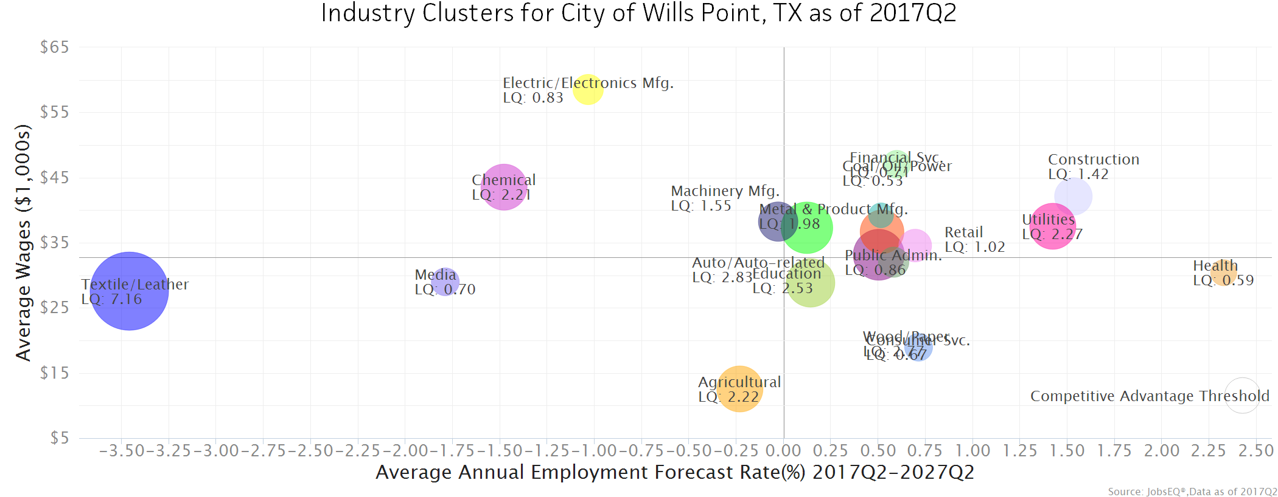
Location quotient and average wage data are derived from the Quarterly Census of Employment and Wages, provided by the Bureau of Labor Statistics, imputed where necessary, and updated through 2016Q4 with preliminary estimates updated to 2017Q2. Forecast employment growth uses national projections from the Bureau of Labor Statistics adapted for regional growth patterns.

Education Levels
Expected growth rates for occupations vary by the education and training required. While all employment in the City of Wills Point, TX is projected to grow 0.6% over the next ten years, occupations typically requiring a postgraduate degree are expected to grow 0.8% per year, those requiring a bachelor’s degree are forecast to grow 0.5% per year, and occupations typically needing a 2-year degree or certificate are expected to grow 1.3% per year.
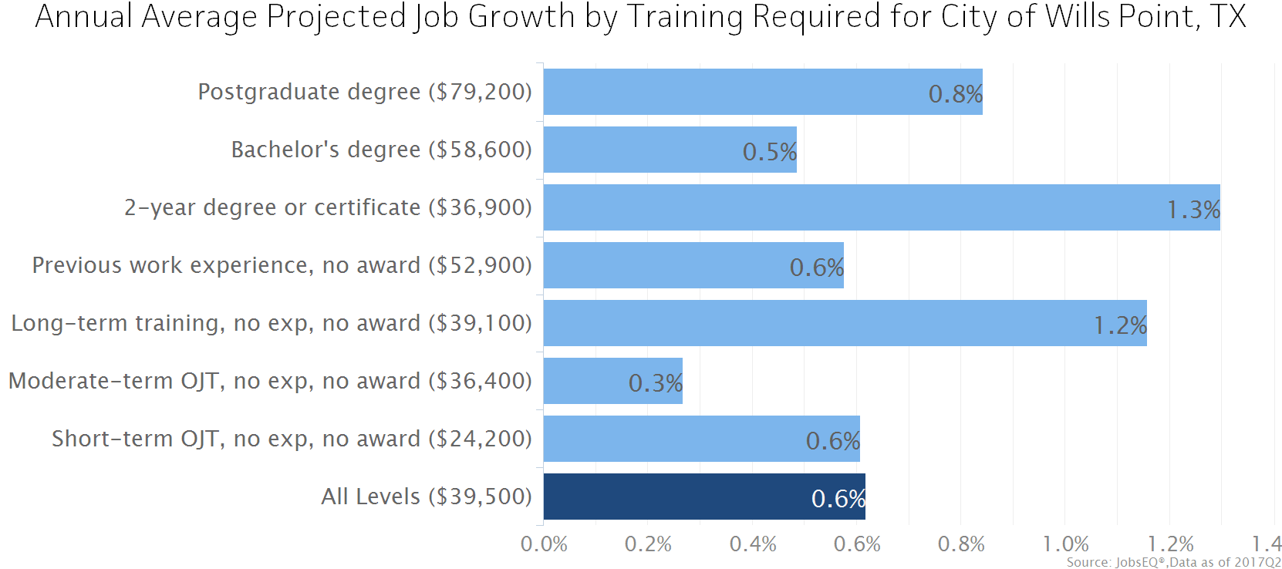
Employment by occupation data are estimates are as of 2017Q2. Education levels of occupations are based on BLS assignments. Forecast employment growth uses national projections from the Bureau of Labor Statistics adapted for regional growth patterns.

FAQ
What is a location quotient?
A location quotient (LQ) is a measurement of concentration in comparison to the nation. An LQ of 1.00 indicates a region has the same concentration of an industry (or occupation) as the nation. An LQ of 2.00 would mean the region has twice the expected employment compared to the nation and an LQ of 0.50 would mean the region has half the expected employment in comparison to the nation.
What is replacement demand?
Replacement demand is the number of jobs required due to replacements—retirements and turnover resulting from workers moving from one occupation into another. Note that replacement demand does not include all turnover—it does not include when workers stay in the same occupation but switch employers. The replacement demand shown in this report may also be understated; thus, it can be taken to be a minimum measure of the number of workers who will need to be trained for the occupation due to replacements. The total projected demand for an occupation is the sum of the replacement demand and the growth demand (which is the increase or decrease of jobs in an occupation expected due to expansion or contraction of the overall number of jobs in that occupation).
What is a cluster?
A cluster is a geographic concentration of interrelated industries or occupations. If a regional cluster has a location quotient of 1.25 or greater, the region is considered to possess a competitive advantage in that cluster.
What is the difference between industry wages and occupation wages?
Industry wages and occupation wages are estimated via separate data sets, often the time periods being reported do not align, and wages are defined slightly differently in the two systems (for example, certain bonuses are included in the industry wages but not the occupation wages). It is therefore common that estimates of the average industry wages and average occupation wages in a region do not match exactly.
What is NAICS?
The North American Industry Classification System (NAICS) is used to classify business establishments according to the type of economic activity. The NAICS Code comprises six levels, from the “all industry” level to the 6-digit level. The first two digits define the top level category, known as the “sector,” which is the level examined in this report.
What is SOC?
The Standard Occupational Classification system (SOC) is used to classify workers into occupational categories. All workers are classified into one of over 820 occupations according to their occupational definition. To facilitate classification, occupations are combined to form 23 major groups, 96 minor groups, and 449 occupation groups. Each occupation group includes detailed occupations requiring similar job duties, skills, education, or experience.

About This Report
This report and all data herein were produced by JobsEQ®, a product of Chmura Economics & Analytics. The information contained herein was obtained from sources we believe to be reliable. However, we cannot guarantee its accuracy and completeness.

